What’s NeMo?

NeMo is an open-source Software for the processing and the analysis of images of cells, in particular neuron cells. NeMo is an acronysm for “Neuron Morphological tool”.
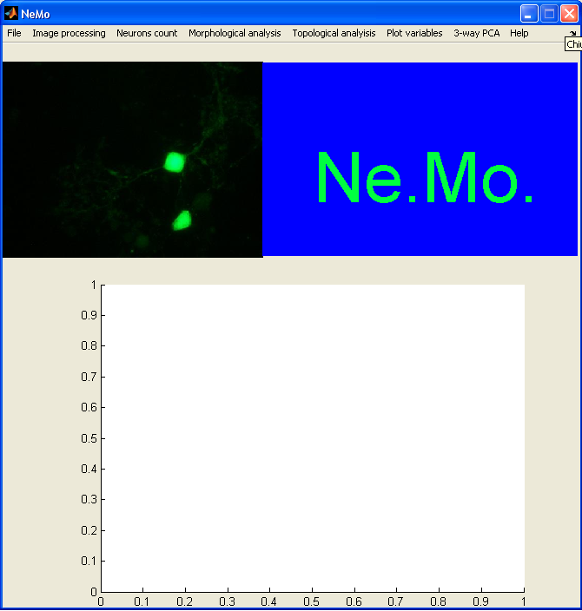
Ne.Mo is a good help to analyze neuron cells. These are, in fact, involved in morphological and topological alterations in pathologies like autism.
Our objective was to have an user-friendly graphical interface, that can also be used by people who don’t know Matlab or other programming languages.
Ne.Mo. is simple to use, but is a valid and accurate instrument for static and dynamic analysis.

With this tool, it’s possible to extract some information about cell morphology from images representing single neurons, network or slices.
After you have load an image in the tool, you can:
- Processing it to obtain binary image and cell skeleton;
- Counting the cells in the image;
- Analyze neuron morphology
- Analyze slice topology;
For both the kind of analysis, , the aim is to extract parameters that can be considered important for the comparison between different group of cells;
- Plot the numerical results;
- Perform a statistical analysis by 3-way PCA.

For more information see:
  - Help “How organize folders in Ne.Mo.”
  - Help “Image processing”
  - Help “neurons count”
  - Help “Neuron Morphological analysis tool”

